Chapter 08: Advanced User Registration

At this point we have the standard Django user registration implemented. But often that’s just the starting point on professional projects. What about customizing things a bit? For example, Django’s default username/email/password pattern is somewhat dated these days. It’s far more common to simply require email/password for sign up and log in. And really every part of the authentication flow–the forms, emails, pages–can be customized if so desired.

Another major factor in many projects is the need for social authentication, that is handling sign up and log in via a third-party service like Google, Facebook, and so on.
We could implement our own solutions here from scratch but there are some definite risks: user registration is a complex area with many moving parts and one area where we really do not want to make a security mistake.

For this reason, many professional Django developers rely on the popular third-party djangoallauth. Adding any third party package should come with a degree of caution since you are adding another dependency to your technical stack. It’s important to make sure any package is both up-to-date and well tested. Fortunately django-allauth is both.

At the cost of a little bit of magic it addresses all of these concerns and makes customization much, much easier.

django-allauth
We will install django-allauth in the usual manner. Start off by adding it to the existing
requirements.txt file.
requirements.txt
asgiref==3.5.2
Django==4.0.4
psycopg2-binary==2.9.3
sqlparse==0.4.2
django-crispy-forms==1.14.0
crispy-bootstrap5==0.6
django-allauth==0.50.0

Then spin down the currently running Docker container, rebuild our Docker image, and start up a new container.
docker-compose down
docker-compose up -d --build

Our website will still function the same as before since we haven’t explicitly told Django about this new django-allauth package. To do that we need to update the INSTALLED_APPS config within our django_project/settings.py file adding Django’s built-in, but optional, sites framework, allauth, and its account feature, allauth.account.

django-allauth also requires an update to Django’s AUTHENTICATION_BACKENDS. By default, Django includes ModelBackend which is needed to login by username in the Django admin. django-allauth needs its own additional backend, AuthenticationBackend, so users can login by e-mail.

Here is what the complete updates look like in the django_project/settings.py file.
# django_project/settings.py
INSTALLED_APPS = [
"django.contrib.admin",
"django.contrib.auth",
"django.contrib.contenttypes",
"django.contrib.sessions",
"django.contrib.messages",
"django.contrib.staticfiles",
"django.contrib.sites", # new
# Third-party
"crispy_forms",
"crispy_bootstrap5",
"allauth", # new
"allauth.account", # new
# Local
"accounts.apps.AccountsConfig",
"pages.apps.PagesConfig",
]

# django-crispy-forms
CRISPY_ALLOWED_TEMPLATE_PACKS = "bootstrap5"
CRISPY_TEMPLATE_PACK = "bootstrap5"
# django-allauth config
SITE_ID = 1 # new

AUTHENTICATION_BACKENDS
The settings.py file created by Django for any new project contains a number of explicit
settings–those that we see in the file already–as well as a longer additional list of implicit settings that exist but aren’t visible. This can be confusing at first. The complete list of settings configurations is available here.

An example is the AUTHENTICATION_BACKENDS setting. Under the hood Django sets this to 'django.contrib.auth.backends.ModelBackend', which is used when Django attempts to authenticate a user. We could add the following line to django_project/settings.py and the current behavior would remain unchanged:
AUTHENTICATION_BACKENDS = (
"django.contrib.auth.backends.ModelBackend",
)
However, for django-allauth we need to add its specific authentication options, too, which will allow us to switch over to using login via e-mail in a moment. At the bottom of your django_project/settings.py file add the following section:
# django_project/settings.py
# django-allauth config
SITE_ID = 1
AUTHENTICATION_BACKENDS = (
"django.contrib.auth.backends.ModelBackend",
"allauth.account.auth_backends.AuthenticationBackend", # new
)

EMAIL_BACKEND
Another configuration implicitly set by is EMAIL_BACKEND. By default Django will look for a configured SMTP server to send emails.

django-allauth will send such an email upon a successful user registration, which we can and will customize later, but since we don’t yet have a SMTP server properly configured, it will result in an error.

The solution, for now, is to have Django output any emails to the command line console instead. Thus we can override the default, implicit config by using console instead of smtp. Add this at the bottom of the settings.py file.
# django_project/settings.py
# django-allauth config
SITE_ID = 1
AUTHENTICATION_BACKENDS = (
"django.contrib.auth.backends.ModelBackend",
"allauth.account.auth_backends.AuthenticationBackend",
)
EMAIL_BACKEND = "django.core.mail.backends.console.EmailBackend" # new

ACCOUNT_LOGOUT_REDIRECT
There’s one more subtle change to make to our configurations at this time. If you look at the configurations page again you’ll see there is a setting for ACCOUNT_LOGOUT_REDIRECT that defaults to the path of the homepage at /.

In our current settings.py file we have the following two lines for redirects which point to the homepage via its URL name of "home".
# django_project/settings.py
LOGIN_REDIRECT_URL = "home"
LOGOUT_REDIRECT_URL = "home"

The issue is that django-allauth’s ACCOUNT_LOGOUT_REDIRECT actually overrides the built-in LOGOUT_REDIRECT_URL but since they both point to the homepage this change may not be immediately apparent. To future-proof our application–since maybe we don’t want to alwaysredirect to the homepage on logout–we should be explicit here with the logout redirect.

We can also move the two redirect lines under our django-allauth config section. This is what the entire django-allauth config section should look like at this time.
# django_project/settings.py
# django-allauth config
LOGIN_REDIRECT_URL = "home"
ACCOUNT_LOGOUT_REDIRECT = "home" # new
SITE_ID = 1
AUTHENTICATION_BACKENDS = (
"django.contrib.auth.backends.ModelBackend",
"allauth.account.auth_backends.AuthenticationBackend",
)
EMAIL_BACKEND = "django.core.mail.backends.console.EmailBackend"

Given that we have made many changes to our django_project/settings.py file let’s now run migrate to update our database.
docker-compose exec web python manage.py migrate
Operations to perform:
Apply all migrations: account, accounts, admin, auth, contenttypes, sessions, sites
Running migrations:
Applying account.0001_initial... OK
Applying account.0002_email_max_length... OK
Applying sites.0001_initial... OK
Applying sites.0002_alter_domain_unique... OK

URLs
We also need to swap out the built-in auth app URLs for django-allauth’s own allauth app. We’ll use the same accounts/ URL path, however, since we’ll be using django-allauth’s templates and routes for sign up we can delete the URL path for our accounts app, too.
# django_project/urls.py
from django.contrib import admin
from django.urls import path, include
urlpatterns = [
# Django admin
path("admin/", admin.site.urls),
# User management
path("accounts/", include("allauth.urls")), # new
# Local apps
path("", include("pages.urls")),
]

At this point we could further delete accounts/urls.py and accounts/views.py which were both created solely for our hand-written sign up page and are no longer being used.
Templates

Django’s auth app looks for templates within a templates/registration directory, but allauth prefers they be located within a templates/account directory. So we will create a new directory called templates/account and then copy over our existing login.html and signup.html templates into it.
mkdir templates/account
mv templates/registration/login.html templates/account/login.html
mv templates/registration/signup.html templates/account/signup.html

It’s easy to add an s onto account here by accident, but don’t or you’ll get an error. The correct directory is templates/account/.

We can delete the templates/registration directory at this point since it is no longer needed.
rm -r templates/registration

rm means remove and -r means do it recursively, which is necessary whenever you are dealing with a directory. If you’d like further information on this command you can type man rm to read the manual.

Note that if you ever see a command that includes rm -rf–and especially sudo rm -rf–use incredible caution! It is possible to wipe your entire computer with this command. Don’t ever execute it unless you are 100% sure the result is intended.

The last step is to update the URL links within templates/_base.html to use django-allauth’s URL names rather than Django’s. We do this by adding an account_ prefix so Django’s 'logout' will now be 'account_logout', 'login' will be 'account_login', and signup will be account_signup.
<!-- templates/_base.html -->
…
<ul class="navbar-nav me-auto mb-2 mb-md-0">
<li class="nav-item">
<a class="nav-link" href="{% url 'about'}">About</a>
</li>
{% if user.is_authenticated %}
<li class="nav-item">
<a class="nav-link" href="{% url 'account_logout' %}">Log Out</a>
</li>
{% else %}
<li class="nav-item">
<a class="nav-link" href="{% url 'account_login' %}">Log In</a>
</li>
<li class="nav-item">
<a class="nav-link" href="{% url 'account_signup' %}">Sign Up</a>
</li>
{% endif %}
</ul>
…

And we’re done!

Log In
Refresh the homepage at http://127.0.0.1:8000, log out if you are already logged in, and click on the “Log in” link. The Log In page is now updated page.
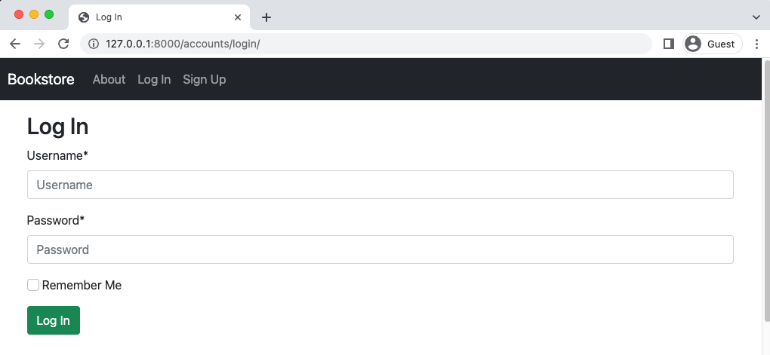

Log In Page

Note the new “Remember Me” box option. This is the first of many configurations that django-allauth provides. The default None asks the user if they want their session to be remembered so they don’t have to log in again. It can also be set to False to not remember or True to always remember. We’ll choose True which is how a traditional Django log in page would work.

Under the # django-allauth config section of the django_project/settings.py file add a new line for this.
# django_project/settings.py
# django-allauth config
...
ACCOUNT_SESSION_REMEMBER = True # new

Refresh the “Log In” page and the box is gone!
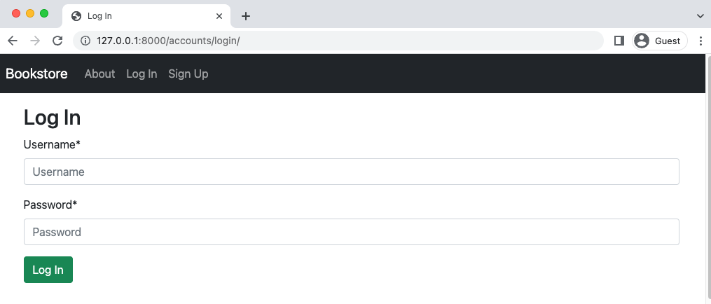
Log In Page No Box

If you try out the log in form with your superuser account it will redirect back to the homepage with a welcome message. Click on the “Log Out” link.
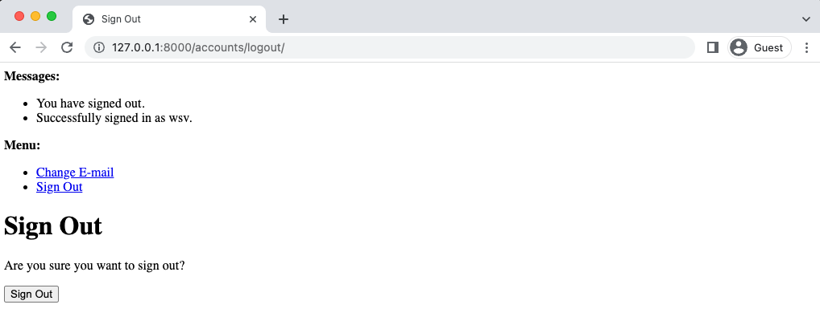
Log Out Page

Rather than directly log us out, django-allauth has an intermediary “Log Out” page which we can customize to match the rest of our project.

Log Out
We will now update the default Log Out template by creating a templates/account/logout.html
file to override it. Do so now in your text editor. As in our other templates it will extend
_base.html and include Bootstrap styling on the submitted button.
<!-- templates/account/logout.html -->
{% extends "_base.html" %}
{% load crispy_forms_tags %}

{% block title %}Log Out{% endblock title %}

{% block content %}
<h1>Log Out</h1>
<p>Are you sure you want to log out?</p>
<form method="post" action="{% url 'account_logout' %}">
{% csrf_token %}
{{ form|crispy }}
<button class="btn btn-danger" type="submit">Log Out</button>
</form>
{% endblock content %}

Go ahead and refresh the page.
Custom Log Out Page

Then click on the “Log Out” link to complete the process.

Sign Up
At the top of our website, in the nav bar, click on link for “Sign Up” which has Bootstrap and django-crispy-forms styling.
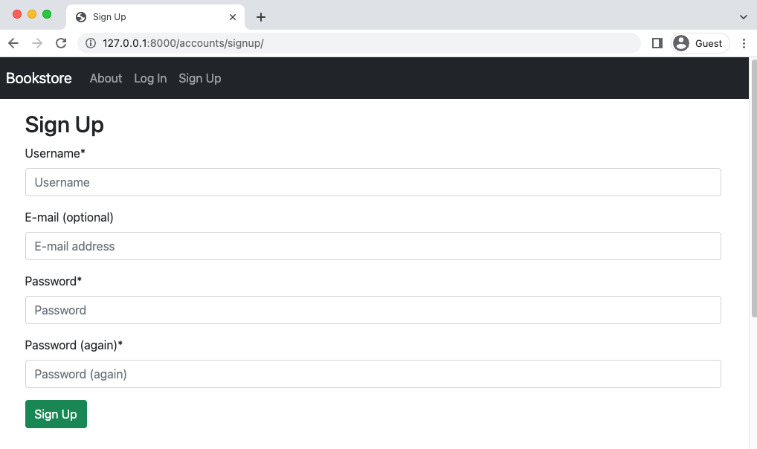Sign Up Page

An optional customization we can make via django-allauth is to only ask for a password once. Since we’ll configure password change and reset options later, there’s less of a risk that a user who types in the password incorrectly will be locked out of their account.

This change is, if you look at the django-allauth configuration options, is a one-liner.

# django_project/settings.py
# django-allauth config
...
ACCOUNT_SIGNUP_PASSWORD_ENTER_TWICE = False # new

Refresh the page and the form will update itself to remove the additional password line.
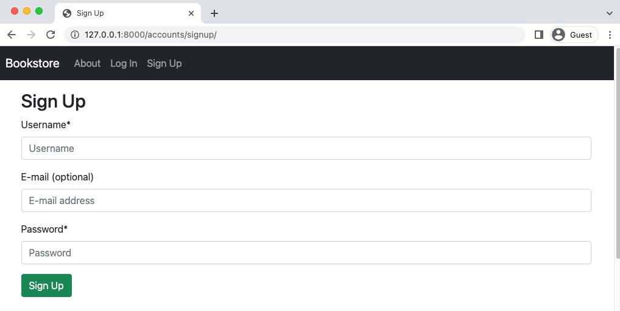
Sign Up with Single Password

Now create a new user to confirm everything works. We can call the user testuser1, use testuser1@email.com as email, and testpass123 as the password. Upon submit it will redirect you to the homepage.

Remember how we configured email to output to the console? django-allauth automatically sends an email upon registration which we can view by typing docker-compose logs.
docker-compose logs
...
web_1 | Content-Type: text/plain; charset="utf-8"
web_1 | MIME-Version: 1.0
web_1 | Content-Transfer-Encoding: 7bit
web_1 | Subject: [example.com] Please Confirm Your E-mail Address
web_1 | From: webmaster@localhost
web_1 | To: testuser1@email.com
web_1 | Date: Tue, 17 May 2022 14:04:15 -0000
web_1 | Message-ID: <155266195771.15.17095643701553564393@cdab877c4af3>
web_1 |
web_1 | Hello from example.com!
web_1 |
web_1 | You're receiving this e-mail because user testuser1 has given yours as
an e-mail address to connect their account.
web_1 |
web_1 | To confirm this is correct, go to http://127.0.0.1:8000/accounts/
confirm-emailMQ:1h4oIn:GYETeK5dRClGjcgA8NbuOoyvafA/
web_1 |
web_1 | Thank you from example.com!
web_1 | example.com
web_1 | -----------------------------------------------------------------------
...

There it is. Later on in the book we will customize this message and configure a proper email service to send it to actual users.

Admin
Log in to the admin with your superuser account at http://127.0.0.1:8000/admin/ and we can see it, too, has changed now that django-allauth is involved.
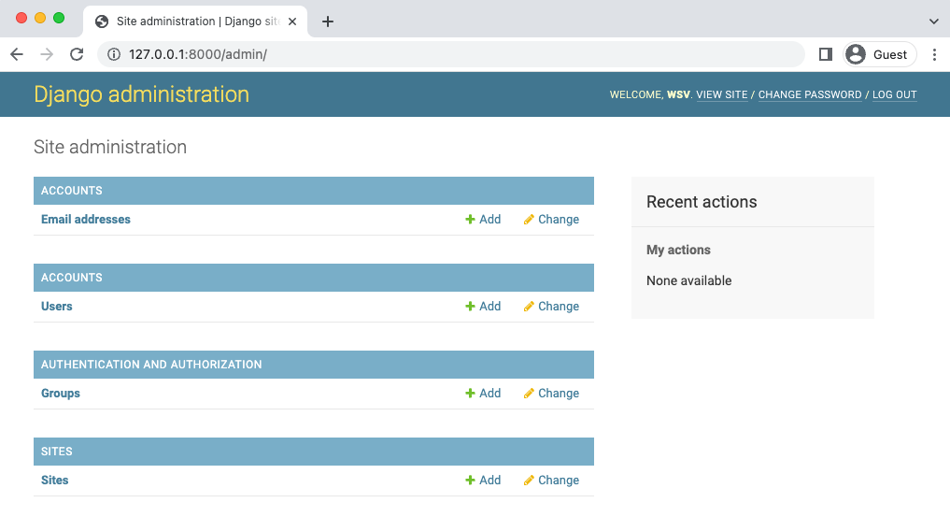
Admin Homepage

There are two new sections: Accounts and Sites courtesy of our recent work. If you click on the Users section we see our traditional view that shows the three current user accounts.
Admin Users

If you expand the admin sidebar on the leftside of the page we can go directly to the Sites section to see what the Django sites framework provides. We’ll update both the Domain Name and the Display Name in a later chapter on configuring email.
Admin Sites
Email Only Login
It’s time to really use django-allauth’s extensive list of configurations by switching over to using just email for login, not username. This requires a few changes. First we’ll make a username not required, but set email instead to required. Then we’ll require email to be unique and the authentication method of choice.
Code
# django_project/settings.py
# django-allauth config
...
ACCOUNT_USERNAME_REQUIRED = False # new
ACCOUNT_AUTHENTICATION_METHOD = "email" # new
ACCOUNT_EMAIL_REQUIRED = True # new
ACCOUNT_UNIQUE_EMAIL = True # new

Navigate back to the homepage and click on “Log Out” since you’ll be logged in with your superuser account. Then click on the navbar link for “Sign Up” and create an account for testuser2@email.com with testpass123 as the password.

After being redirected to the homepage upon success, go into the admin to inspect what actually happened. Log in with your superuser account and navigate to the Users section.
Admin Users
We can see that django-allauth automatically populated a username for us based on the email part before the @. This is because our underlying CustomUser model still has a username field. We didn’t delete it.

While this approach may seem a little hackish in fact it works just fine. Fully removing the username from the custom user model requires the use of AbstractBaseUser, which is an additional, optional step some developers take. It requires far more coding and understanding so it is not recommended unless you really know your way around Django’s authentication system!

There is, however, an edge case here that we should look into: what happens if we have testuser2@email.com and then a sign up for testuser2@example.com? Wouldn’t that result in a username of testuser2 for both which would cause a conflict? Let’s try it out!

Log out of the admin, on the Sign Up Page create an account for testuser2@example.com.
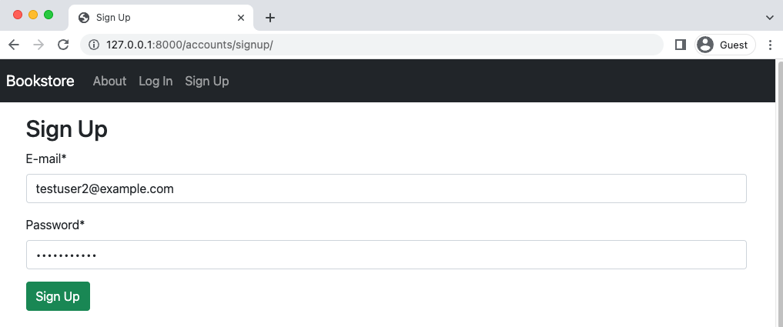
Sign Up Form

Now log back into the admin and go to our Users section.
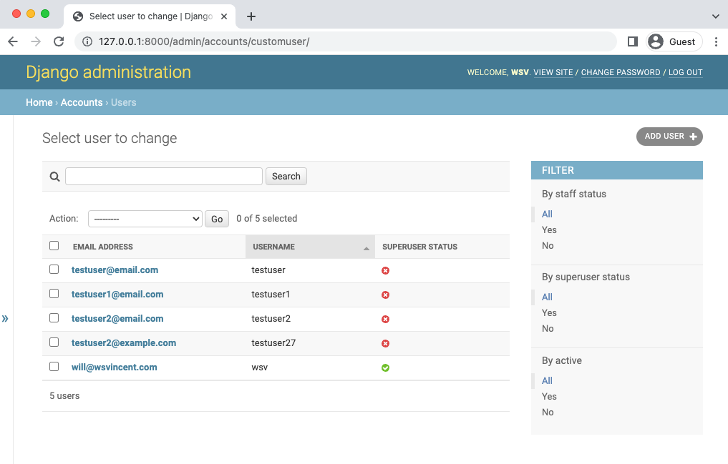
Admin Users
django-allauth automatically adds a two-digit string to the username. In this case it is 20 so testuser2 becomes testuser21. This two-digit string will be randomly generated for us.

Tests
Time for tests. Like any good third-party package django-allauth comes with its own tests so we don’t need to re-test its core functionality, just confirm that our project works as expected.

There are several errors now with our current tests though related to SignUpPageTests since we’re using django-allauth now for this rather than our own views, forms, and urls.
Let’s update the tests. Starting at the top we are no longer using CustomUserCreationForm or SignupPageView so we can remove both imports. We are using django-allauth’s URL path and name now for the sign up page which is account_signup, not the signup we named it previously. How did that it was account_signup? I looked at the source code and found the URL name.

The updated code looks as follows:
# accounts/tests.py
from django.contrib.auth import get_user_model
from django.test import TestCase
from django.urls import reverse, resolve
class CustomUserTests(TestCase):
...
class SignupPageTests(TestCase): # new
username = "newuser"
email = "newuser@email.com"

def setUp(self):
url = reverse("account_signup")
self.response = self.client.get(url)

def test_signup_template(self):
self.assertEqual(self.response.status_code, 200)
self.assertTemplateUsed(self.response, "account/signup.html")
self.assertContains(self.response, "Sign Up")
self.assertNotContains(self.response, "Hi there! I should not be on the page.")

def test_signup_form(self):
new_user = get_user_model().objects.create_user(self.username, self.email)
self.assertEqual(get_user_model().objects.all().count(), 1)
self.assertEqual(get_user_model().objects.all()[0].username, self.username)
self.assertEqual(get_user_model().objects.all()[0].email, self.email)

Run the tests again.
docker-compose exec web python manage.py test
Creating test database for alias 'default'...
System check identified no issues (0 silenced).
..............
----------------------------------------------------------------------
Ran 14 tests in 0.410s
OK
Destroying test database for alias 'default'...

Social
If you want to add social authentication it’s just a few settings. I have a complete tutorial online for integrating Github. The process is similar for Google, Facebook, and all the rest django-allauth supports. Here is the complete list of providers.

Git
As always commit the code changes with Git.
git init
git status
git add .
git commit -m "Chapter 08. Advanced User Registration"

To push to GitHub if you have an account:
1. run: cd ..
Your path should be where you root depository is(in my case Bookstore-by-Chapter):
PS C:\Users\computer’s username\Documents\your main folder\Bookstore-by-Chapter>
Yours would be different like:
PS C:\Users\computer’s username\Documents\your main folder\title of your subfolder>

git add "Chapter 08. Advanced User Registration"
git commit -m "Chapter 08. Advanced User Registration"
git push
And if there are any issues, compare with the official source code on Github.

Create a back up:

Copy-Item -Recurse -Path "C:\Users\Jean-Marc H\Documents\Django for professionals\Bookstore-by-Chapter\Chapter x. chapter’s title" -Destination "C:\Users\Jean-Marc H\Documents\Django for professionals\Bookstore-by-Chapter\ Chapter x. chapter’s title - Backup"

Conclusion
We now have a user registration flow that works and can be quickly extended into social authentication if needed. In the next chapter we’ll add environment variables to our project for greater security and flexibility.

The end.

